CSCI/CMPE 4301 DIP Guide
Jupytor notebook
Exam-04 Name:

- (60) Given the enclosed data set (100 data points each with two dimensional values), with no labels as a csv file
  - Open the file and name the columns feature1, feature2.
    - X = pd.read_csv(‘fname', names=('feature1', 'feature2'))
  - The rows are the number of samples.
  - You must use your own created algorithm based on the class notes, see page cv-11.
  - use the two features.
  - Use 3 random centroids.
  - Use the L2 norm for computing the nearest centroid.
    - Calculate the MSE, which equals to the average distance of the samples to their current centroids based on L2 norm.
  - Stop either after n iter or when the mse does not change by much.
  - Draw the initial and the final centroids.
  - Draw the final clusters.

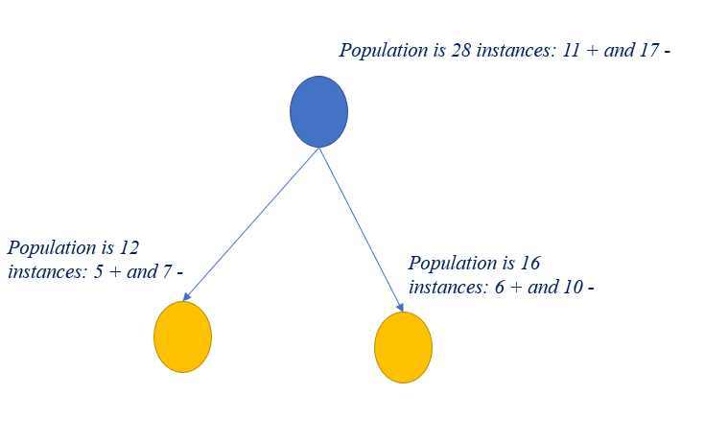
- (40) Based on the Gain in Impurity formula, given the following node with current members (with their classification (+/-) with respect to hypothesis such as the person is healthy or not, you should be able to computer the gain in impurity based on the entropy property
  - Show all the details for full credit.
    - Formula and calculations

